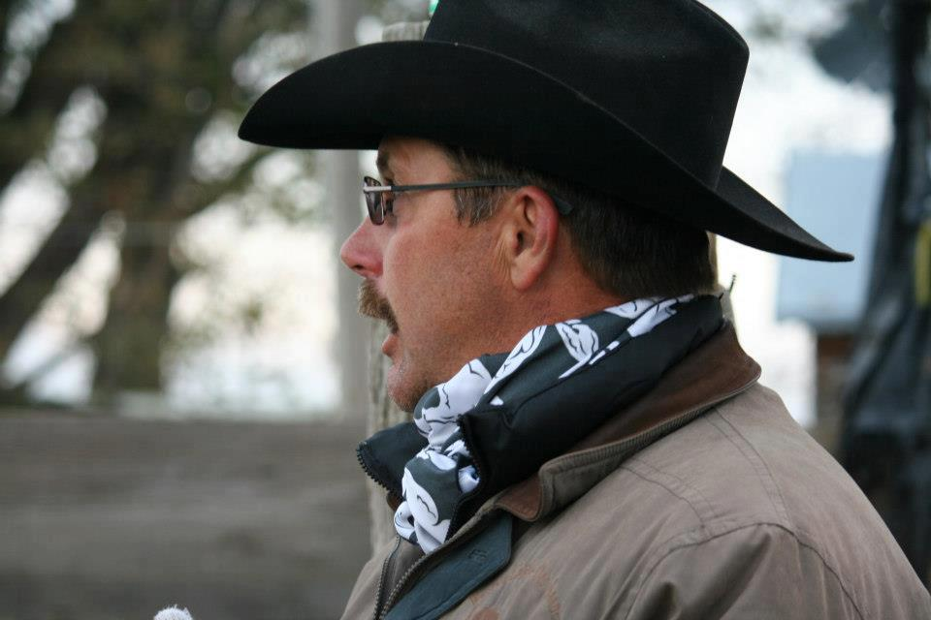
TOM BLASDELL 3rd ANNUAL STOCK DOG CLINIC
May 7 & 8, 2016
11435 Hwy. 95, Payette, Idaho
Tom Blasdell loves working and training stock dogs. He has spent many years buckarooing around Oregon, Washington, Idaho, and California on large cattle ranches. He has trained dogs as well as starting colts and BLM mustangs. This experience has given him the opportunity to see that every animal is an individual and needs to be read differently. Every day is a teaching and learning experience. Tom has learned that if read right, a dog can change its working style to different types of stock, using its rating ability. In the past 25 years the stock dog training has surpassed the horse training, allowing Tom the time needed to create good canine ranch hands in several different states for other people. He is a master at reading stock and has done very well at cattle dog trials. He has won several of the largest trials on the west coast; Champion Nursery Dog of the year 2 times, Reserve Champion Nursery Dog of the Year, Klamath Falls Bull Sale challenge dog 3 times, Fort Klamath Rodear Open Reserve Championship & Open Championship, Winnemucca Rancher (Nursery) 2 times & Harvest Festival Cow Dog Classic Nursery Champion.
This clinic is open to 12 dog/handler teams. Open to all breeds & training levels, from beginner to advanced. Work on developing basic commands on young/ inexperienced dogs, or fine tune an advanced or problem dog. Entrance fee is $150.00 per day per team, or $225 for the weekend and includes lunch. You may run a different dog in any of the training sessions at no extra cost. Spectators /auditing fee $25.00/day and includes lunch. Participants with dogs are welcome to watch training sessions that may not be appropriate for their dog(s) now. Appropriate stock (goats, sheep, cattle) will be available for all levels of dogs/handlers. ALL DOGS MUST BE LEASHED UNLESS WORKING. Clinic starts at 8:30 a.m. Please Tufstockdogs.com bring a chair, beverage of choice, and any special snacks you may want. Coffee, water, pastries, and fruit will be provided in the morning and lunch will be provided mid-day. Questions? Please contact Lyle at 208-739-8301 or email kyotireddog@gmail.com.
**************************************************************************************************
Make checks payable to Carol Gerken and mail to 11435 Hwy. 95, Payette, ID 83661 with the Entry Form by May 1 to reserve your space! This clinic will fill FAST! Entries will be taken on a first paid basis and no space will be held without payment. $50.00 non-refundable as a deposit. Once full, we will start a waiting list.
Handler w/dog ____ Auditing____ Name ___________________________Phone__________________________
Address___________________________________________________________________________________
Dog’s Name_______________________ Age___________Stock Preference ____________________________
Entrant acknowledges with entry that working with animals may involve potential for accident and/or injury and enters this clinic at their own risk.

